*Testing Fundamentals Name: Ch.Vinay Kiran*

*Mini project 2 : Performance Testing on a Landing page.*

*Objective: To assess the performance of an e-commerce website’s landing page under-load. As the objective of this performance test is to evaluate the page load time of our website under a simulated user load. The primary goal is to ensure that the website is running smoothly with responding to the users within the acceptable time frames, when multiple users access the website simultaneously.*

*Performance Testing: A vital component of software development is performance testing, which evaluates an application's functionality under various circumstances. Finding possible challenges, making the most use of available resources, and making sure the program satisfies performance standards are its main objectives.*

*Load Testing: The load testing is the sub-test of the performance testing as in the load testing the system is simulated to a load (Different loads: low users, medium users and high users) in order to gauge its response. It aids in ascertaining how the system will behave in both typical and predicted peak load scenarios.*

*Test Environment : Apache JMeter*

*Website URL:- https://www.lego.com/en-in*

*Test Tool: Apache JMeter.*

*Test Environment: Production-like environment*

*Metrics: Page load time in milliseconds*

*Test Scenarios: Performing the load testing by various number of users. To the e-commerce website to test performance of the website under-load.*

*Low-Load-Testing: The Low-load-testing is performed, when the virtual users are minimal. It measures the e-commerce web-page load time under normal conditions.*

*Number of users: 25*

*Excepted Outcome: Established a minimal baseline for the web-page load time.*

*Low Load Test: 44*

*Medium-load-test: The medium load testing is performed, when the virtual users are above the minimal acceptance count of the users.*

*Number of users: 50*

*Excepted Outcome: Established a medium load test successfully for the web-page.*

*Medium Load Test: 48*

*High Load Test: The High load testing is performed, when the virtual users exceed the acceptance count of users accessing the web-page.*

*Number of users: 100*

*Excepted Outcome: Successfully measured the high-load-test for the e-commerce web-page under heavy load.*

*High-Load-Test: 57*

*Test-Execution: The Steps involved in the process of performing the performance testing to the e-commerce website under-load. Set up Apache JMeter using the above mentioned test cases. Step-by-step carry out each test scenario while keeping an eye on the website load time for every user load level. For analysis, note the performance metrics.*

*Analysis and validation: Check whether the page load time for each test scenario satisfies the performance requirements by analyzing the recorded data.   
List any performance problems or limitations that you noticed during the tests.   
Create a performance test report that summarizes the results and, if needed, offers improvement suggestions.*

*Conclusion: The purpose of the performance test is to guarantee that, under various user load conditions, the homepage of the website loads within reasonable time constraints. The performance of the website can be optimized by carrying out the test plan and evaluating the outcomes to find any problems with performance.*

*Low-User-Under-Load-Test:*

**

*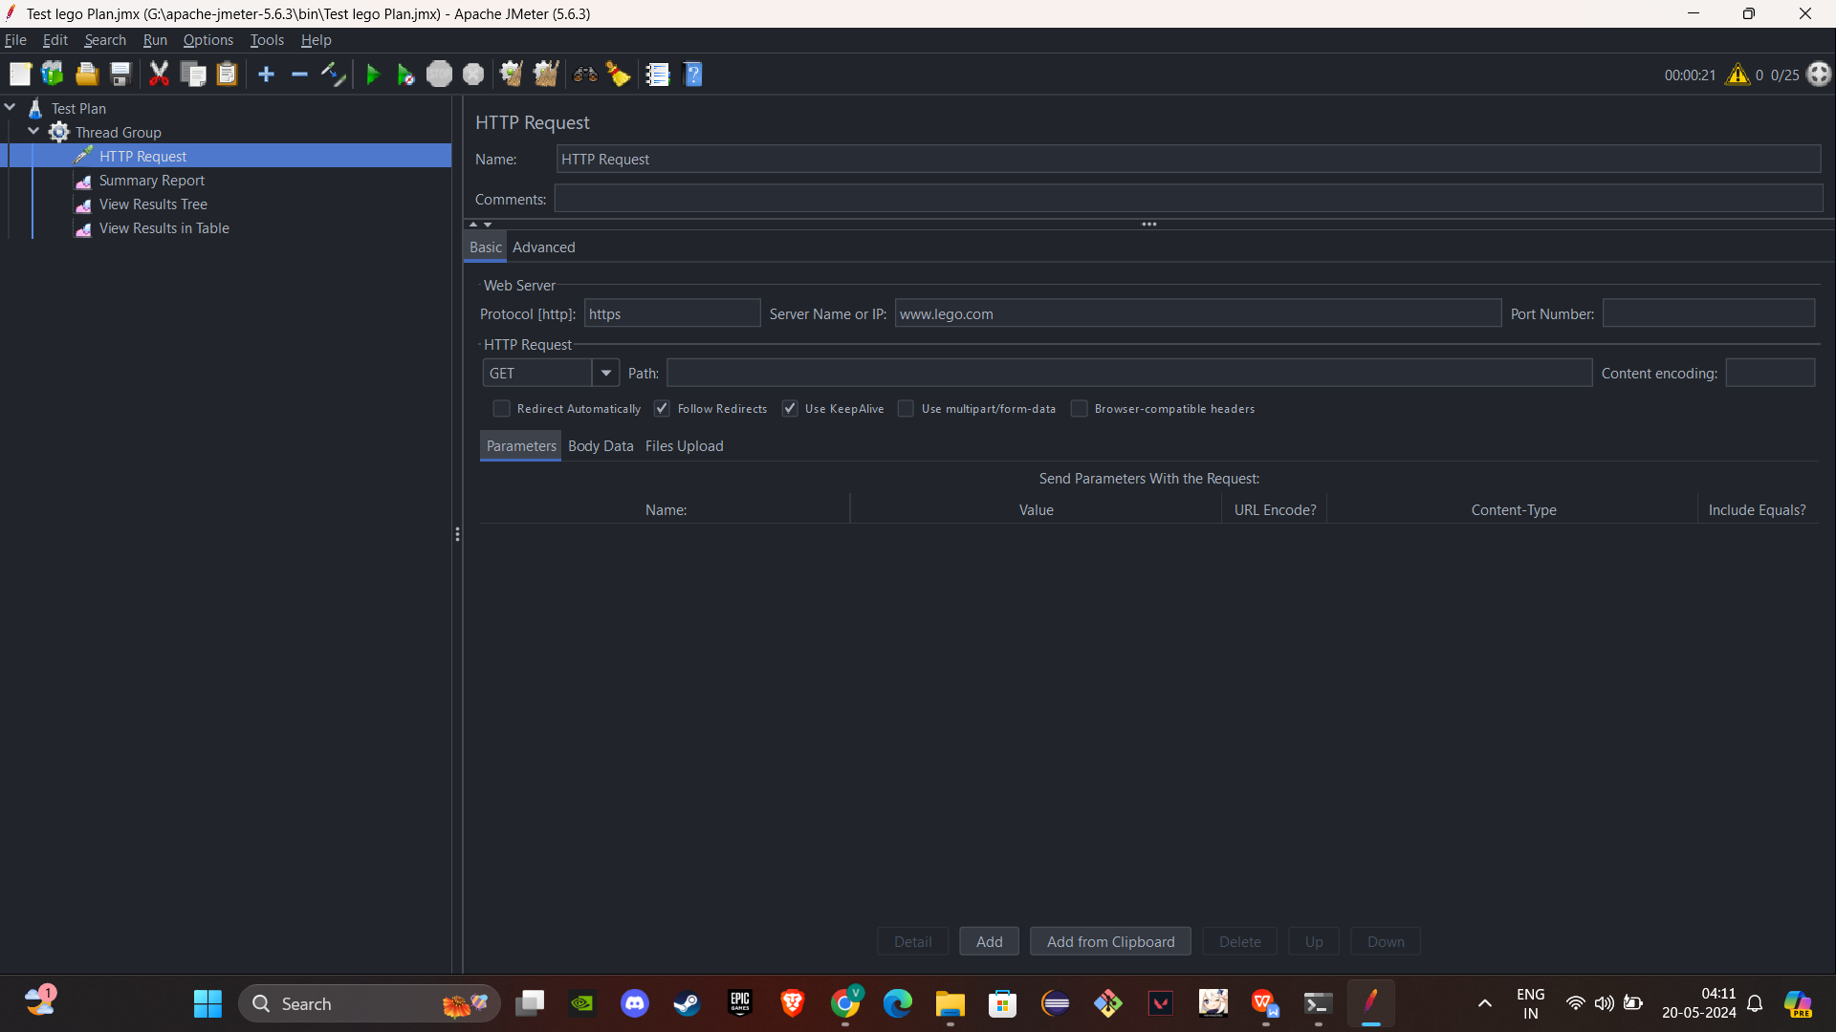*

**

*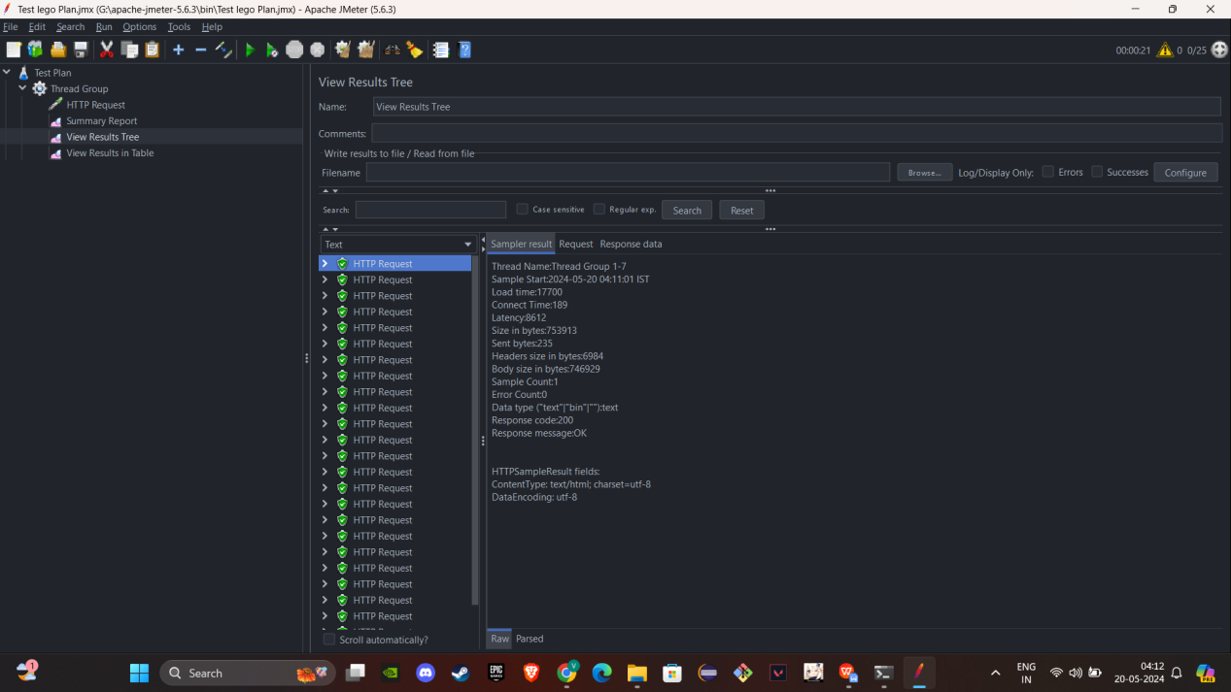*

*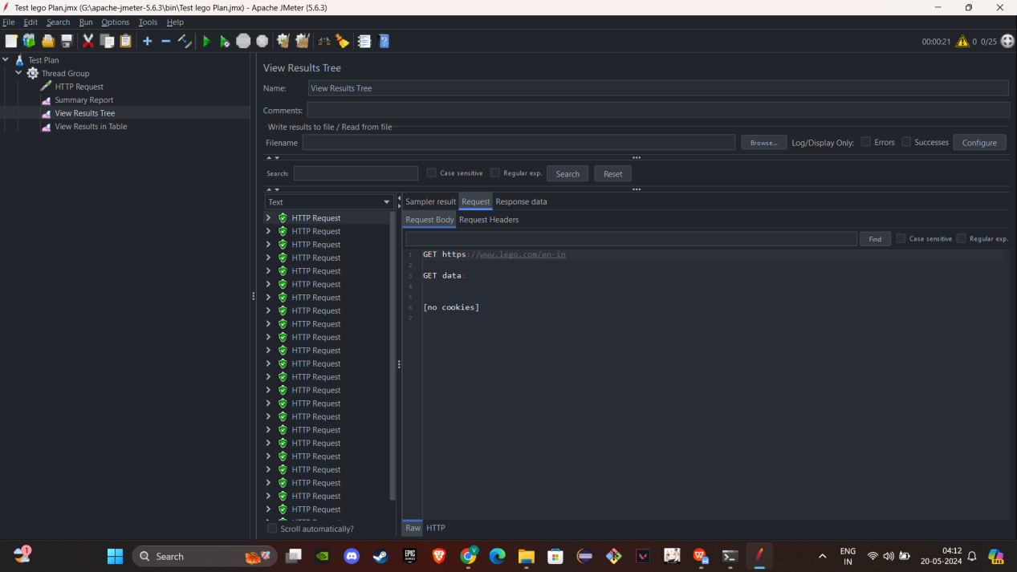*

*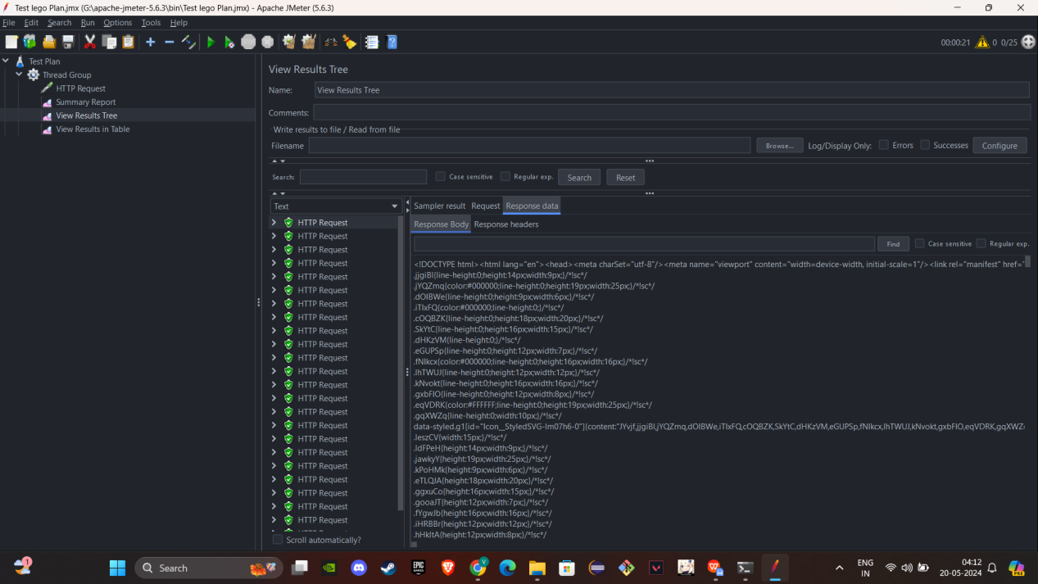*

*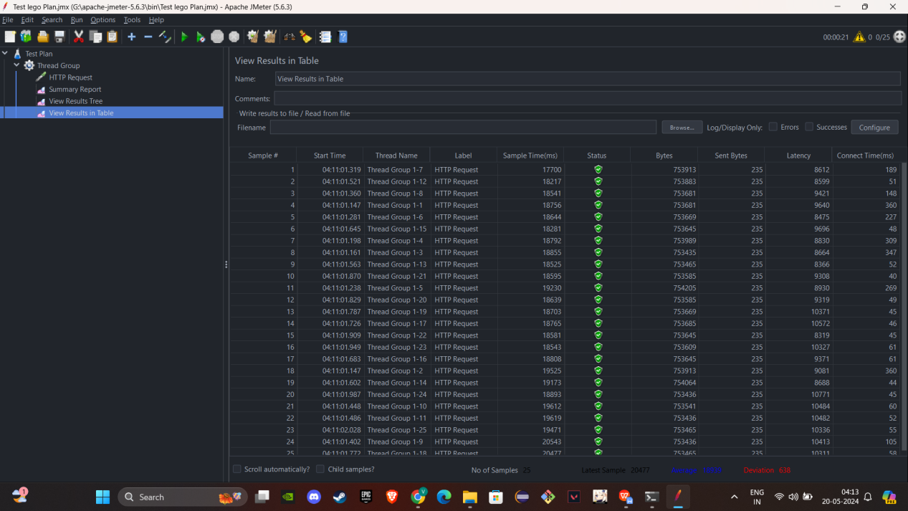*

*Medium-User-Under-Load-Test:*

**

*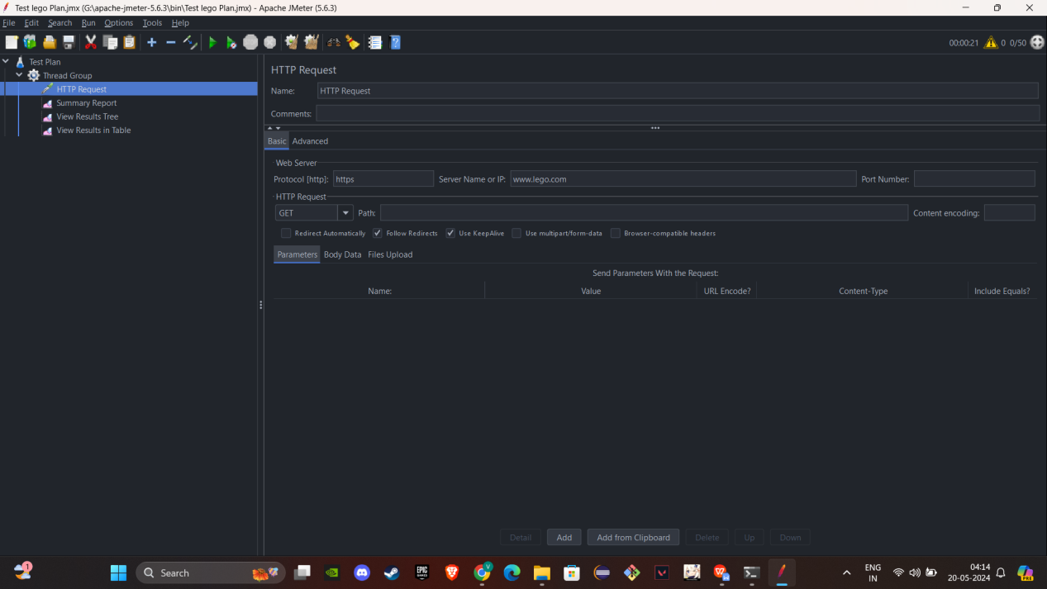*

*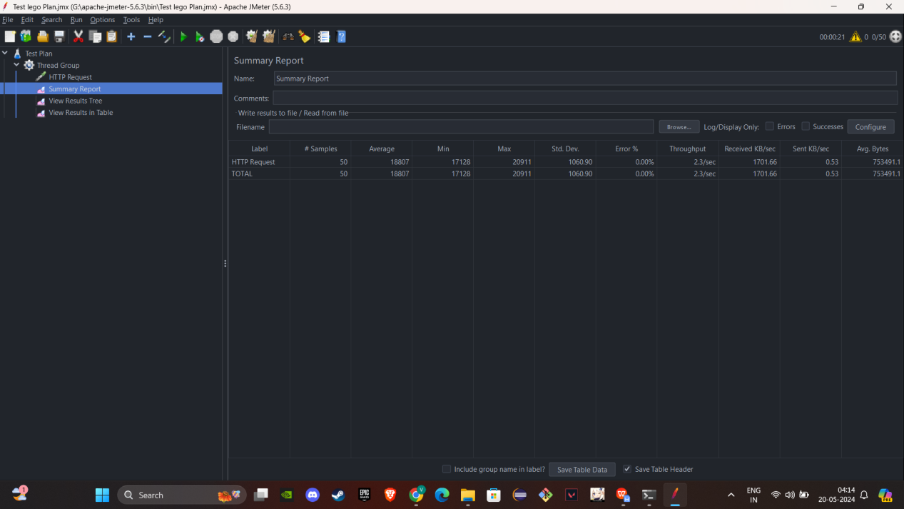*

*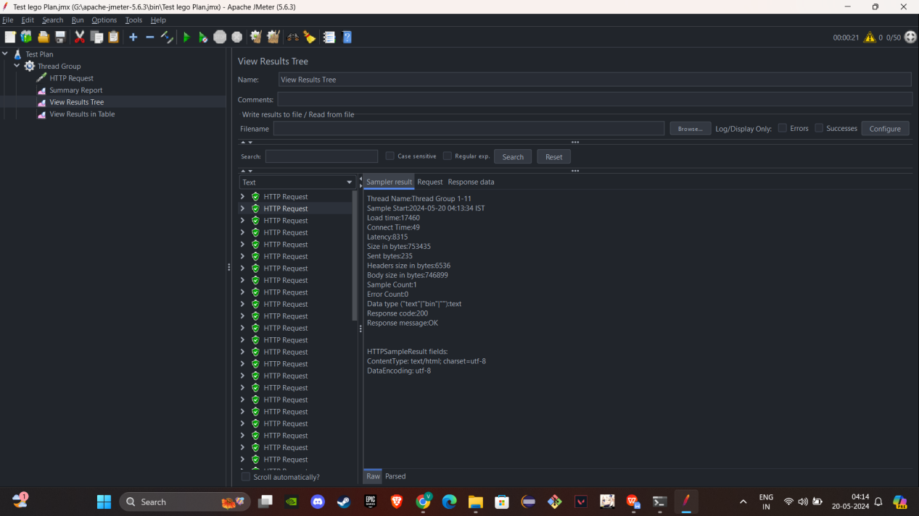*

*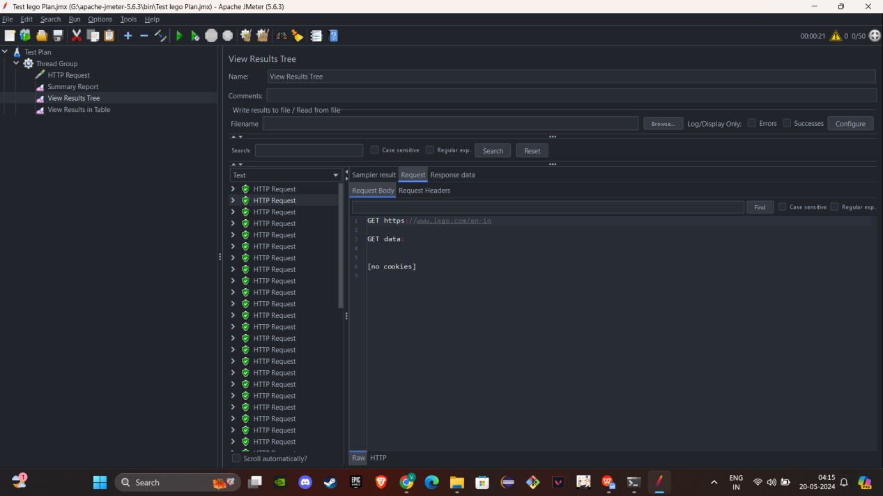*

*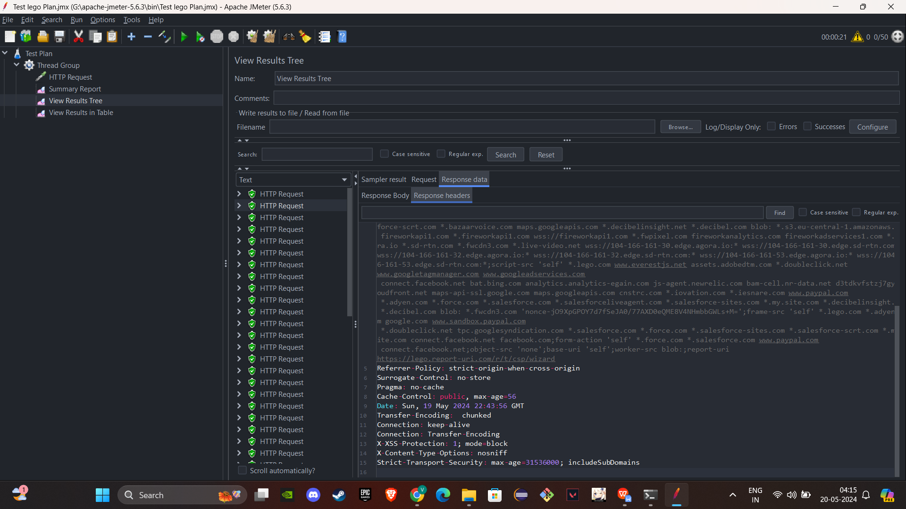*

*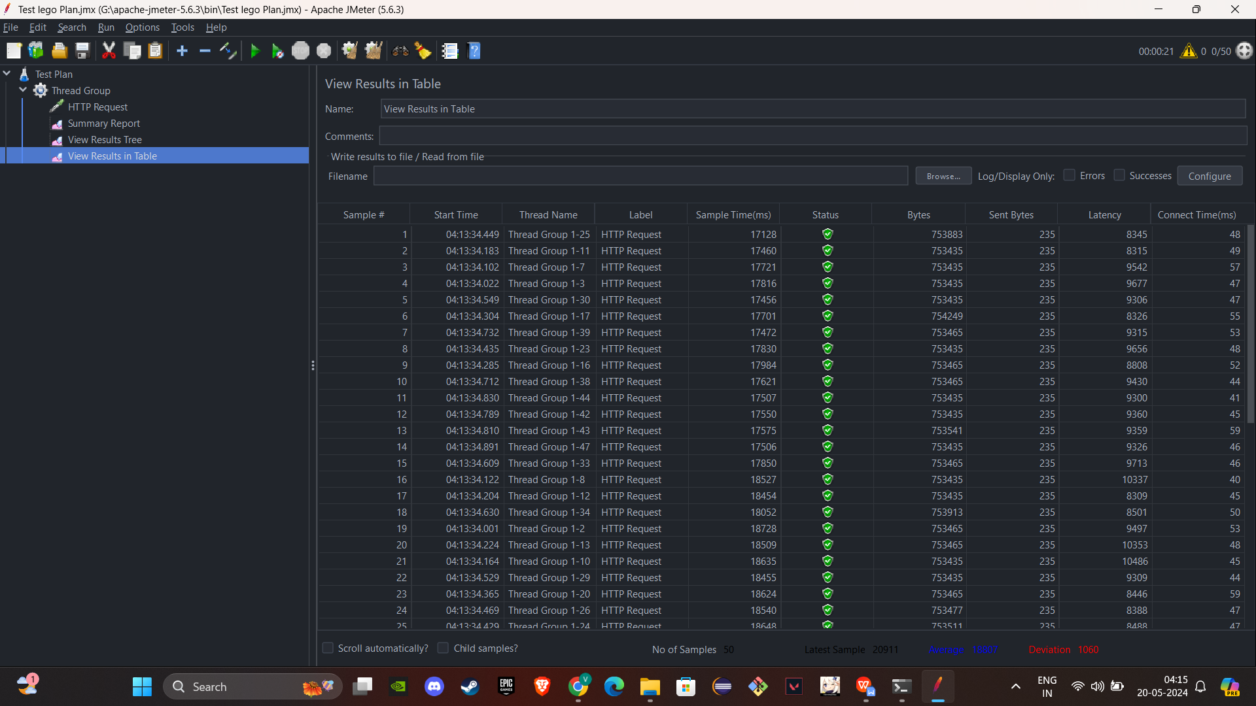*

*High-User-Under-load-testing:*

**

*